Caroline Williams and Robert Kearney

4/13/2021

IDCE 30306

[CaWilliams@clarku.edu](mailto:CaWilliams@clarku.edu) and [RKearney@clarku.edu](mailto:RKearney@clarku.edu)

Assessing the Vulnerability of Populations in Vietnam to Tropical Cyclones

**Abstract**

This paper examines the vulnerability of populations in Vietnam to tropical cyclones. Using the IPCC framework on exposure, sensitivity, and adaptive capacity, we examine the current vulnerability in comparison to mitigation strategies. A wide variety of climate, socioeconomic, and environmental data was utilized to analyze each component, exposure, sensitivity, and adaptive capacity, individually. Exposure and sensitivity were then aggregated to a vulnerability index and presented against adaptive capacity. We used the statistical package R and ArcGIS Pro, for our multi-criteria analysis and visualization. This study finds that the northern coastline of Vietnam, from Ninh Bình to Quảng Ninh, is experiencing both high vulnerability to cyclone events, but also high adaptive capacity due to the presence of mangroves. Therefore, we recommend increasing protected areas in this region to better mitigate the effects of tropical cyclone events in Vietnam.

**Introduction**

With increasing anthropogenic climate change, Vietnam is one of the most severely impacted countries by changes in tropical cyclone intensity and frequency (Tinh & Tuan, 2015). In particular, Vietnam is greatly exposed to the West Pacific Basin which is the most active basin and features the highest human mortality risk (Kossin, Emanuel, & Camargo, 2016). Coupled with a long coastline at 3260 km, populations in Vietnam are highly susceptible to experiencing cyclone events (Takagi et al., 2012). Additionally, among the disasters Vietnam faces, roughly 80% of them are attributed to tropical cyclone events (Takagi et al., 2012). As cyclone intensity and frequency change, Vietnamese populations will surely be impacted, thus defining the need to map and assess the vulnerability to tropical cyclone events.

In addition to tropical cyclone exposure, Vietnam is characterized by mangrove forests dispersed throughout the coastline. Mangrove forests are an essential ecosystem between terrestrial and marine systems by protecting coastal communities (Ellison & Zouh, 2012). Specifically, mangroves act as a barrier to tropical cyclones and storm events by reducing incoming wave energy and preventing erosion (Ellison & Zouh, 2012). Mangroves are increasingly threatened by anthropogenic activities and climate change making them susceptible to rising sea levels and changes in precipitation (Ellison & Zouh, 2012; Tinh & Tuan, 2015). These ecosystems are also vulnerable to conversion to pond aquaculture, thereby dampening the protection they have against extreme storm events and reducing the adaptive capacity of coastal communities against tropical cyclone events (Ellison & Zouh, 2012). It is expected that reforestation efforts will continue to decrease in Vietnam, thus reducing the benefits of these ecosystems in mitigating storm events (Nguyen & Parnell, 2019; Tinh & Tuan, 2015). With increased exposure to tropical cyclones and potential for mangrove land degradation, it is crucial to examine the vulnerability using spatial analysis.

The effectiveness of vulnerability assessments has been well documented and widely used to identify strategies and allocate resources to mitigation efforts (Weis et al., 2016). Vulnerability research often incorporates the components, exposure, sensitivity, and adaptive capacity as a spatial decision-framework (de Sherbinin et al., 2019; Weis et al., 2016). Initially derived from the IPCC, exposure is defined as the magnitude and rate of climate variations to which a system is exposed, sensitivity is the degree to which a system could be affected by climate-related stimuli, and adaptive capacity is the ability of a system to adjust or cope with climate change consequences (Torresan, Critto, Rizzi, & Marcomini, 2012). This framework is incorporated into this analysis by combining the exposure and sensitivity components resulting in vulnerability to compare against the adaptive capacity component in Vietnam (Figure 1). Additionally, this research utilizes previous research, particularly Ali et al., as a guideline in defining threshold values for the variables incorporated in this study (Ali, Khatun, Ahmad, & Ahmad, 2019). This study examines the current vulnerability of Vietnam to tropical cyclone events using mangroves as an approach for adaptive capacity measures.

*Problem Statement*

This study aims to define the vulnerability of populations in Vietnam to tropical cyclones and identify strategies that would help mitigate the impacts of future tropical cyclone events. This includes examining the presence of mangrove ecosystems as a form of mitigation. This study examines the exposure, sensitivity, and adaptive capacity of populations in Vietnam via a vulnerability index. Furthermore, this study will identify mitigation strategies and provide potential guidance to reduce overall population vulnerability.

*Objectives*

1. Create a vulnerability index including an analysis on the exposure, sensitivity, and adaptive capacity of populations in Vietnam to tropical cyclones
2. Provide maps and guidelines to mitigate impacts of cyclone events

**Data**

This study utilizes a wide assortment of spatial data including tropical cyclones, mangrove forests, precipitation, and population data (Table 1). NOAA’s International Best Track Archive for Climate Stewardship (IBTrACS) version 4 dataset was utilized to produce temporal profiles of cyclones affecting Vietnam as well as continuous surface raster imagery. This data includes shapefiles, both point and line, as well as csv and netCDF file formats. Precipitation data was retrieved from WorldClim and is in GeoTIFF file format at 10, 5, and 2.5 minutes and 30 seconds spatial resolution. Elevation was obtained from SRTM and also in GeoTIFF format. The spatial resolution is also available at 10, 5, and 2.5 minutes and 30 seconds. Mangrove extent was acquired from Clark Labs in GeoTIFF at 15 meters resolution. This dataset also included land classification for pond aquaculture and other wetlands. Administrative boundaries in shapefile format were derived from the United Nations Office for the Coordination of Humanitarian Affairs (OCHA). Additionally, health facilities in Vietnam were from OCHA as shapefiles. From WorldPop, population data was used with GeoTIFFs at 1 km and 100 meters. The land cover dataset used in this study was procured from the European Space Agency (ESA) Climate Change Initiative (CCI) product. Lastly, road data in shapefile format is from Princeton University’s Digital Maps and Geospatial Data.

**Methods**

*Tropical Cyclone Mean Intensity*

Using the IBTrACS dataset, maximum sustained wind speed was used as a proxy for intensity. Often studies utilize tropical cyclone speed as a substitute for intensity, however, faster speeds do not necessarily suggest greater intensity. Slower tropical cyclone speeds over land may induce more devastating impacts on coastal populations due to the increased time of exposure. To assess the temporal changes in intensity, maximum sustained wind speed was averaged using the statistical programming software, R. Following this, cyclone tracks that intersected with Vietnam were disaggregated into individual tracks. Through an iterative process, each track was converted from polyline to raster. A raster stack or group was created of each individual cyclone track from 1980 to present. Although the dataset originates to 1880, maximum sustained wind speed was not calculated until a century later. A mean calculation was then applied to this raster group resulting in a final mean intensity image. This product was produced at 0.5º spatial resolution. This coarse resolution was used to produce similar results to previous studies; additionally, a coarse resolution was implemented for both programmatic reasons, as R uses a large amount of RAM, and to account for the large width of cyclones (Elsner, Hodges, & Jagger, 2012). After reprojecting to WGS 84 UTM 48N at 30 meters, this product was then reclassified using quantile classification methods (Table 2). Low intensity was given a score of 1 to depict low exposure. High intensity was reclassified as 5 to represent high exposure. No data were reclassified as 0 and later represented visually with a Missing Data overlay (Figure 5).

*Tropical Cyclone Frequency*

Tropical Cyclone frequency was processed similarly to tropical cyclone mean intensity. The temporal variation of cyclones was first analyzed in R using a variety of spatial packages. In comparison to tropical cyclone intensity, frequency was examined from 1880 to present. Following this temporal assessment, the sum of observations or tracks was applied to the same raster stack created for mean intensity. This was also examined at 0.5º resolution and later reprojected. Tropical cyclone frequency was reclassified using quantile classification methods (Table 2). Low frequency corresponds to low exposure (1), while high frequency represents high exposure (5) (Figure 6).

*Precipitation*

Using monthly mean precipitation data from WorldClim, R was used to automate clipping this climate data to our Vietnam extent shapefile. After, annual precipitation was produced for each year from 2000 to 2018. These eighteen years were then averaged producing our final precipitation layer. This mean annual precipitation data was then reclassified using natural breaks (Table 2). In the context of tropical cyclones, high precipitation will produce greater impacts on the coast in comparison to lower precipitation, therefore low precipitation represents low exposure. The inverse is also true, with high precipitation equaling high exposure (Figure 7).

*Distance to Coastline*

Distance to Coastline was calculated using the Euclidean Distance tool in ArcGIS Pro. A line feature was extracted by manually splitting the administrative boundary polygon at each terminus of the coastline and used as the input source data. Distance to coastline was then reclassified using the same break points used by Ali et al. (2019) (Table 2) with short distances assigned a score of 5 (very high exposure) and long distances assigned a score of 1 (very low exposure) (Figure 8).

*Elevation*

SRTM elevation data was reclassified into 5 ranked classes using the break points used by Ali et al. (2019) (Table 2). This classification method was chosen because it effectively classifies low elevation areas with a score of 5 (very high exposure) and higher elevation areas with a score of 1 (very low exposure) (Figure 9).

*Slope*

Percent slope was calculated for the SRTM elevation data using the Slope tool in ArcGIS Pro. The resulting slope surface was reclassified into the 5 ranked classes using the break points used by Ali et al. (2019) (Table 2). This classification method was implemented because it effectively classifies gentle slopes with a score of 1 (very low exposure) and steep slopes with a score of 5 (very high exposure) (Figure 10).

*Population Density*

Population density data from WorldPop was reclassified into the 5 ranks using the break points used by Ali et al. (2019) (Table 2) Although the population density data used by Ali et al. (2019) differs from the data used in this study, the units of measurement are consistent. This classification method assigns areas with low densities with a score of 1 (very low exposure) and high densities with a score of 5 (very high exposure) (Figure 11).

*Population Percentage over 65 years old*

The percentage of male and female populations aged 65 and older was calculated using the Raster Calculator tool in ArcGIS Pro and Persons Per Pixel (PPP) data from WorldPop. Careful review of the resulting surface indicates that WorldPop estimates PPP consistently across administrative subdivisions. The raster surface was reclassified into quintiles to include an equal number of observations in each ranked class (Table 2). Low percentages were given a score of 1 (very low sensitivity) and high percentages were given a score of 5 (very high sensitivity) (Figure 12).

*Land Cover and Land Use (LULC)*

LULC data from ESA CCI was manually reclassified using a method that was generally adapted from Ali et al. (2019) (Table 2). While their study included a supervised land cover classification from remotely sensed imagery, this study attempted to use LC data from ESA CCI and ranked land cover classes in a similar way. Due to differences in the number and types of LC classes in the ESA CCI dataset and Ali et al. (2019) study, some classes could not be directly compared. For this study, bare areas (200, 201, 202) and water bodies (210) were given a score of 1 (very low exposure), and urban areas were given a score of 5 (very high exposure) (Figure 13).

*Health Facility Density*

Health facilities included hospitals and clinics while facilities like dentists were excluded. A health facility density layer was produced using Kernel Density in ArcGIS Pro. This output was then reclassified using equal interval (Table 2). Dense areas were counted as low sensitivity while less dense areas were depicted as high sensitivity to tropical cyclones. A score of 1 (low sensitivity) to 5 (high sensitivity) was also used (Figure 14).

*Distance to Roads*

The distance to roads layer was produced using the Euclidean Distance module in ArcGIS Pro. This result was then reclassified using natural breaks with low sensitivity being represented by a shorter distance to roads (1) and greater distances (5) as high sensitivity (Table 2). Populations with less road infrastructure, will likely have greater difficulty evacuating in the case of severe, high intensity tropical cyclones (Figure 15).

*Distance to Mangroves*

Using the pond aquaculture dataset for Vietnam from Clark Labs, the 2018 layer was used to represent the most current extent of mangroves. A Boolean layer was produced extracting mangroves from this land cover dataset. The mangrove 2018 data was then used in the Euclidean Distance module in ArcGIS Pro to produce a final distance to mangroves images. Reclassify was then used with quantile classification methods (Table 2). Low distance to mangroves was represented as high adaptive capacity (5) since the protective nature of this ecosystem will function locally. Areas far from mangroves were depicted as lower adaptive capacity (1) (Figure 16).

*Distance to Protected Areas*

Excluding marine protected areas, terrestrial protected areas were used to identify the adaptive capacity of Vietnam alongside distance to mangroves. Similar to the distance to mangroves analysis, the Euclidean Distance and Reclassify modules in ArcGIS Pro were used. Additionally, quantile classification breaks were implemented (Table 2). Low adaptive capacity (1) was characterized by greater distance to protected areas while high adaptive capacity (5) is represented by short distances to protected areas. Like distance to mangroves, the benefit of protected areas is generally a local function (Figure 17).

*Exposure, Sensitivity, & Adaptive Capacity*

For this purpose of this study, exposure, sensitivity, and adaptive capacity were calculated by combining the factors of each component using the Raster Calculator in ArcGIS Pro. This was accomplished by calculating the sum of all the factors considered for each component (exposure, sensitivity, and adaptive capacity).

*Vulnerability & Adaptive Capacity Indices*

In this study, vulnerability was calculated as the sum of exposure and sensitivity. Due to the differences in the number of factors included in vulnerability and adaptive capacity, indices were created for each component (vulnerability and adaptive capacity) for comparison purposes. Indices ranged from 1 - 5 and were calculated by dividing vulnerability and adaptive capacity by the number of factors included in their respective calculations. In other words, the indices represented the mean of each component.

**Results**

*Vulnerability*

When interpreting the results of the vulnerability index it is important to remember that for the purpose of this research, vulnerability is the mean of all factors considered for exposure and sensitivity. As a result of this calculation methodology, 14 different equally-weighted factors are incorporated in the final result. With so many factors being considered, the resulting image appears as a smooth surface with very few clear breaks in the data. That being said, areas where individual factors influence the final results can be identified with the naked eye. An example of this can be seen in Figure 20. The image shows that in central Vietnam, a clear boundary is visible where a vastly different percent population 65 or older existed along the boundary of two provinces. Furthermore, any areas with missing data values are under-represented in the final result. Upon closer inspection of image, one can see the influence missing data values have on the final result.

High vulnerability index values are concentrated around the major cities of Hanoi and Ho Chi Minh City, as well as in smaller cities along the Gulf of Tonkin and South China Sea. Likewise, low vulnerability index values are concentrated in forested highlands areas, in the western part of the country. Due to tropical cyclones' mean intensity and frequency factors as well as land use and land cover factors, in general, northern Vietnam appears to exhibit higher vulnerability index values than southern Vietnam.

In addition to creating a vulnerability index image, this study also provided two charts describing the long-term trends in tropical cyclone intensity (a) and frequency (b) for Vietnam (Figure 3). Based on these results, there appears to be a flat to slightly downward trend in tropical cyclone intensity from 1980 - Present. Tropical cyclone frequency, however, shows a clear increase from 1880 - present. It is important to note that due to changes in data reporting across time, it is possible that these changes may influence the calculated trends, and that this may be especially true for the tropical cyclone frequency result.

*Adaptive Capacity*

The resulting reclassified distance to mangroves and distance to protected areas maps show coastal areas featuring the greatest adaptive capacity (Figures 16 & 17). Represented equally by these two variables, adaptive capacity is presented (Figure 18). The northern coastline of Vietnam features the one of the highest areas in adaptive capacity. Specifically, from Ninh Bình to Quảng Ninh, there is tremendous capacity to mitigate tropical cyclone events and related disasters. This is attributed to the large presence of mangroves in this region as well as some nearby protected areas inland. The most south and west-facing region of the Vietnam coastline additionally experiences great adaptive capacity, similarly due to a large presence of mangroves. While these two regions feature a similar occurrence on adaptive capacity, there is a notable difference in vulnerability. While the southern region is less vulnerable in the western-facing coast, this can be attributed to missing data which contributes to an underrepresentation of vulnerability at these parts. This study finds that focusing on both the northern coast and southern region for mitigation efforts is most effective and should help aid in protection against future tropical cyclone events.

*Policy Implications*

This study recommends allocating significant resources into developing the extent of protected areas in regions with both high vulnerability and adaptive capacity (Figure 19). Specifically, reforestation and protected area efforts should focus on the administrative areas, Quảng Ninh, Hải Phòng City, Hải Dương, Thái Bình, Nam Định, Ninh Bình, Bạc Liêu, and Cà Mau. We also suggest a need for improving mangrove extent in areas that are high in vulnerability, but lacking in adaptive capacity. This includes areas like Phú Yên, Bình Định, Quảng Bình, and Hà Tĩnh. While we recommend focusing on these administrative areas, it is important to note that these areas should increase in mangrove extent due to its valuable mitigation against tropical cyclones. This study does not focus on alternative benefits of mangrove ecosystems, therefore this study alone can not encompass other factors in deciding reforestation efforts and protected area sites.

**Conclusion**

*Limitations*

The availability of relevant datasets is apparent in the differing number of factors considered for exposure, sensitivity, and adaptive capacity. Under ideal circumstances, this study would have included many more factors for sensitivity and adaptive capacity, which only considered 3 and 2 factors respectively. Missing data also proves to be a major limitation of this analysis. Finally, it is important to mention this type of study is entirely qualitative and that none of the results represent quantitative measures of vulnerability and adaptive capacity. For example, even with data that is quantitative (distance, slope, elevation, density), the values are reclassified and ranked. In the end, these groupings are used to generally compare vulnerability and adaptive capacity across the study area.

*Future Work*

The results of this research demonstrate significant outputs identifying areas of high vulnerability to tropical cyclones and regions most capable of adapting to this risk. Future work should incorporate variables like sea surface temperature (SST) due to its significant relationship with tropical cyclones (Nguyen T, Hoang D., Nguyen X., & Chanh, 2020). Additionally, we recommend future work to include more socio-economic variables for sensitivity and increase the number of variables for adaptive capacity since this study features an uneven allocation of variables between the three components: exposure, sensitivity, and adaptive capacity. Future research should include projected climatic variables to identify vulnerability at different climate scenarios. We recommend using WorldClim’s CMIP6 which includes climate scenarios at different Representative Concentration Pathways (RCPs). Alongside these projected climate variables, we suggest incorporating future land cover data by utilizing Land Change Modeler (LCM) in TerrSet 2020. Examining direction of features like tropical cyclones and mangroves is also preferred. This paper finds that using aggregation based methods alongside the vulnerability framework outlined by the IPCC to be sufficient. We recommend future studies to apply this framework to alternative methods and approaches of aggregating spatial data. Particularly, we suggest methods that greatly remove subjectivity and bias.

**Team Effort**

The GIS analyses, visualizations and writing were evenly split between project members. Specifically, the variables used in creating our indices involved a large amount or preprocessing before aggregating into our final indices. These variables were processed evenly and later combined. Visualizations were split by using a layout file in ArcGIS Pro that incorporate elements of both our cartography styles. In terms of writing, we each focused on areas we worked on the most, specifically in the methods section. The remaining sections were split between us. Lastly, the presentation was separated individually in terms of slides we worked on and presented.

**References**

Ali, S. A., Khatun, R., Ahmad, A., & Ahmad, S. (2019). Assessment of Cyclone Vulnerability,

Hazard Evaluation and Mitigation Capacity for Analyzing Cyclone Risk using GIS Technique: a Study on Sundarban Biosphere Reserve, India. *Earth Systems and Environment, 4*. doi:10.1007/s41748-019-00140-x

Cerveny, R. S., & Newman, L. E. (2000). Climatological Relationships between Tropical

Cyclones and Rainfall. *Monthly Weather Review, 128*(9), 3329-3336. doi:10.1175/1520-0493(2000)128<3329:Crbtca>2.0.Co;2

de Sherbinin, A., Bukvic, A., Rohat, G., Gall, M., McCusker, B., Preston, B., . . . Zhang, S.

(2019). Climate vulnerability mapping: A systematic review and future prospects. *WIREs*

*Climate Change, 10*(5), e600. doi:<https://doi.org/10.1002/wcc.600>

Ellison, J. C., & Zouh, I. (2012). Vulnerability to Climate Change of Mangroves: Assessment

from Cameroon, Central Africa. *Biology, 1*(3), 617-638. doi:10.3390/biology1030617

Elsner, J., Hodges, R., & Jagger, T. (2012). Spatial grids for hurricane climate research. *Climate*

*Dynamics, 39*(1/2), 21-36. doi:10.1007/s00382-011-1066-5

Kossin, J. P., Emanuel, K. A., & Camargo, S. J. (2016). Past and Projected Changes in Western

North Pacific Tropical Cyclone Exposure. *Journal of Climate, 29*(16), 5725-5739.

doi:10.1175/JCLI-D-16-0076.1

Nguyen T, T., Hoang D., C., Nguyen X., H., & Chanh, K. (2020). Relationship between sea

surface temperature and the maximum intensity of tropical cyclones affecting Vietnam's

coastline. *International Journal of Climatology, 40*(5), 2527. doi:10.1002/joc.6348

Nguyen, T. P., & Parnell, K. E. (2019). Coastal land use planning in Ben Tre, Vietnam:

constraints and recommendations. *Heliyon, 5*(4), e01487. doi:10.1016/j.heliyon.2019.e01487

Takagi, H., Thao, N., Esteban, M., Tam, T., Knaepen, H., & Mikami, T. (2012). *Vulnerability of*

*coastal areas in Southern Vietnam against tropical cyclones and storm surges*.

Tinh, P. H., & Tuan, M. S. (2015). Vulnerability to climate change of mangroves in Xuan Thuy

National Park, Vietnam. *Journal of Agricultural and Biological Science, 10*(2), 55-60.

Torresan, S., Critto, A., Rizzi, J., & Marcomini, A. (2012). Assessment of coastal vulnerability to

climate change hazards at the regional scale: the case study of the North Adriatic Sea. *Nat. Hazards Earth Syst. Sci., 12*(7), 2347-2368. doi:10.5194/nhess-12-2347-2012

Weis, S. W. M., Agostini, V. N., Roth, L. M., Gilmer, B., Schill, S. R., Knowles, J. E., & Blyther,

R. (2016). Assessing vulnerability: an integrated approach for mapping adaptive capacity,

sensitivity, and exposure. *Climatic Change, 136*(3), 615-629.

doi:10.1007/s10584-016-1642-0

**Tables**

Table 1. Data was acquired from various sources and originated as both vector and raster data and from varying spatial resolutions.

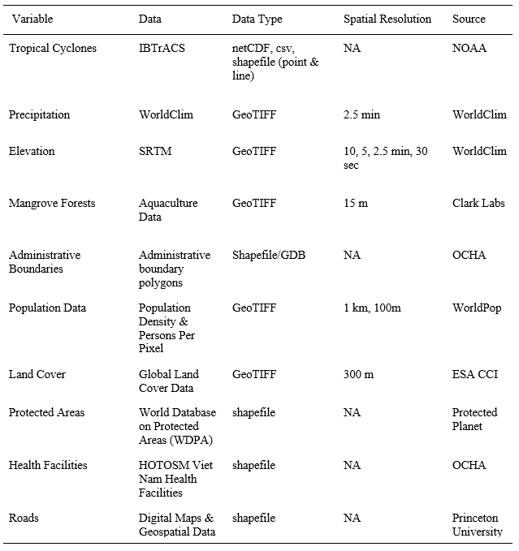

Table 2. Reclassification of exposure, sensitivity, and adaptive capacity variables to a score of 1 to 5: 1 (Very Low), 2 (Low), 3( Moderate), 4 (High), and 5 (Very High).

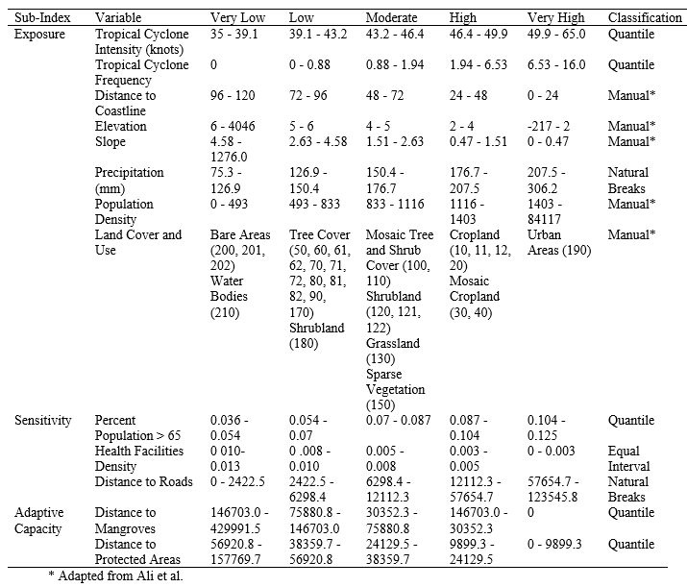

**Figures**

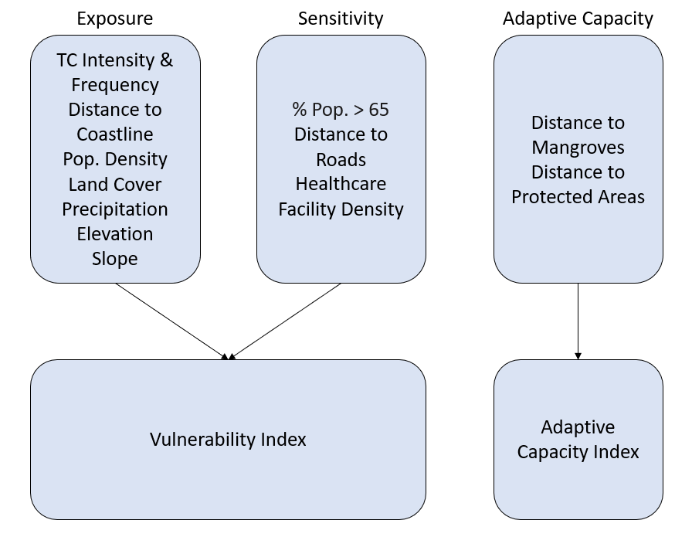

Figure 1. Framework used to assess the vulnerability and adaptive capacity of Vietnam including the incorporated variables.

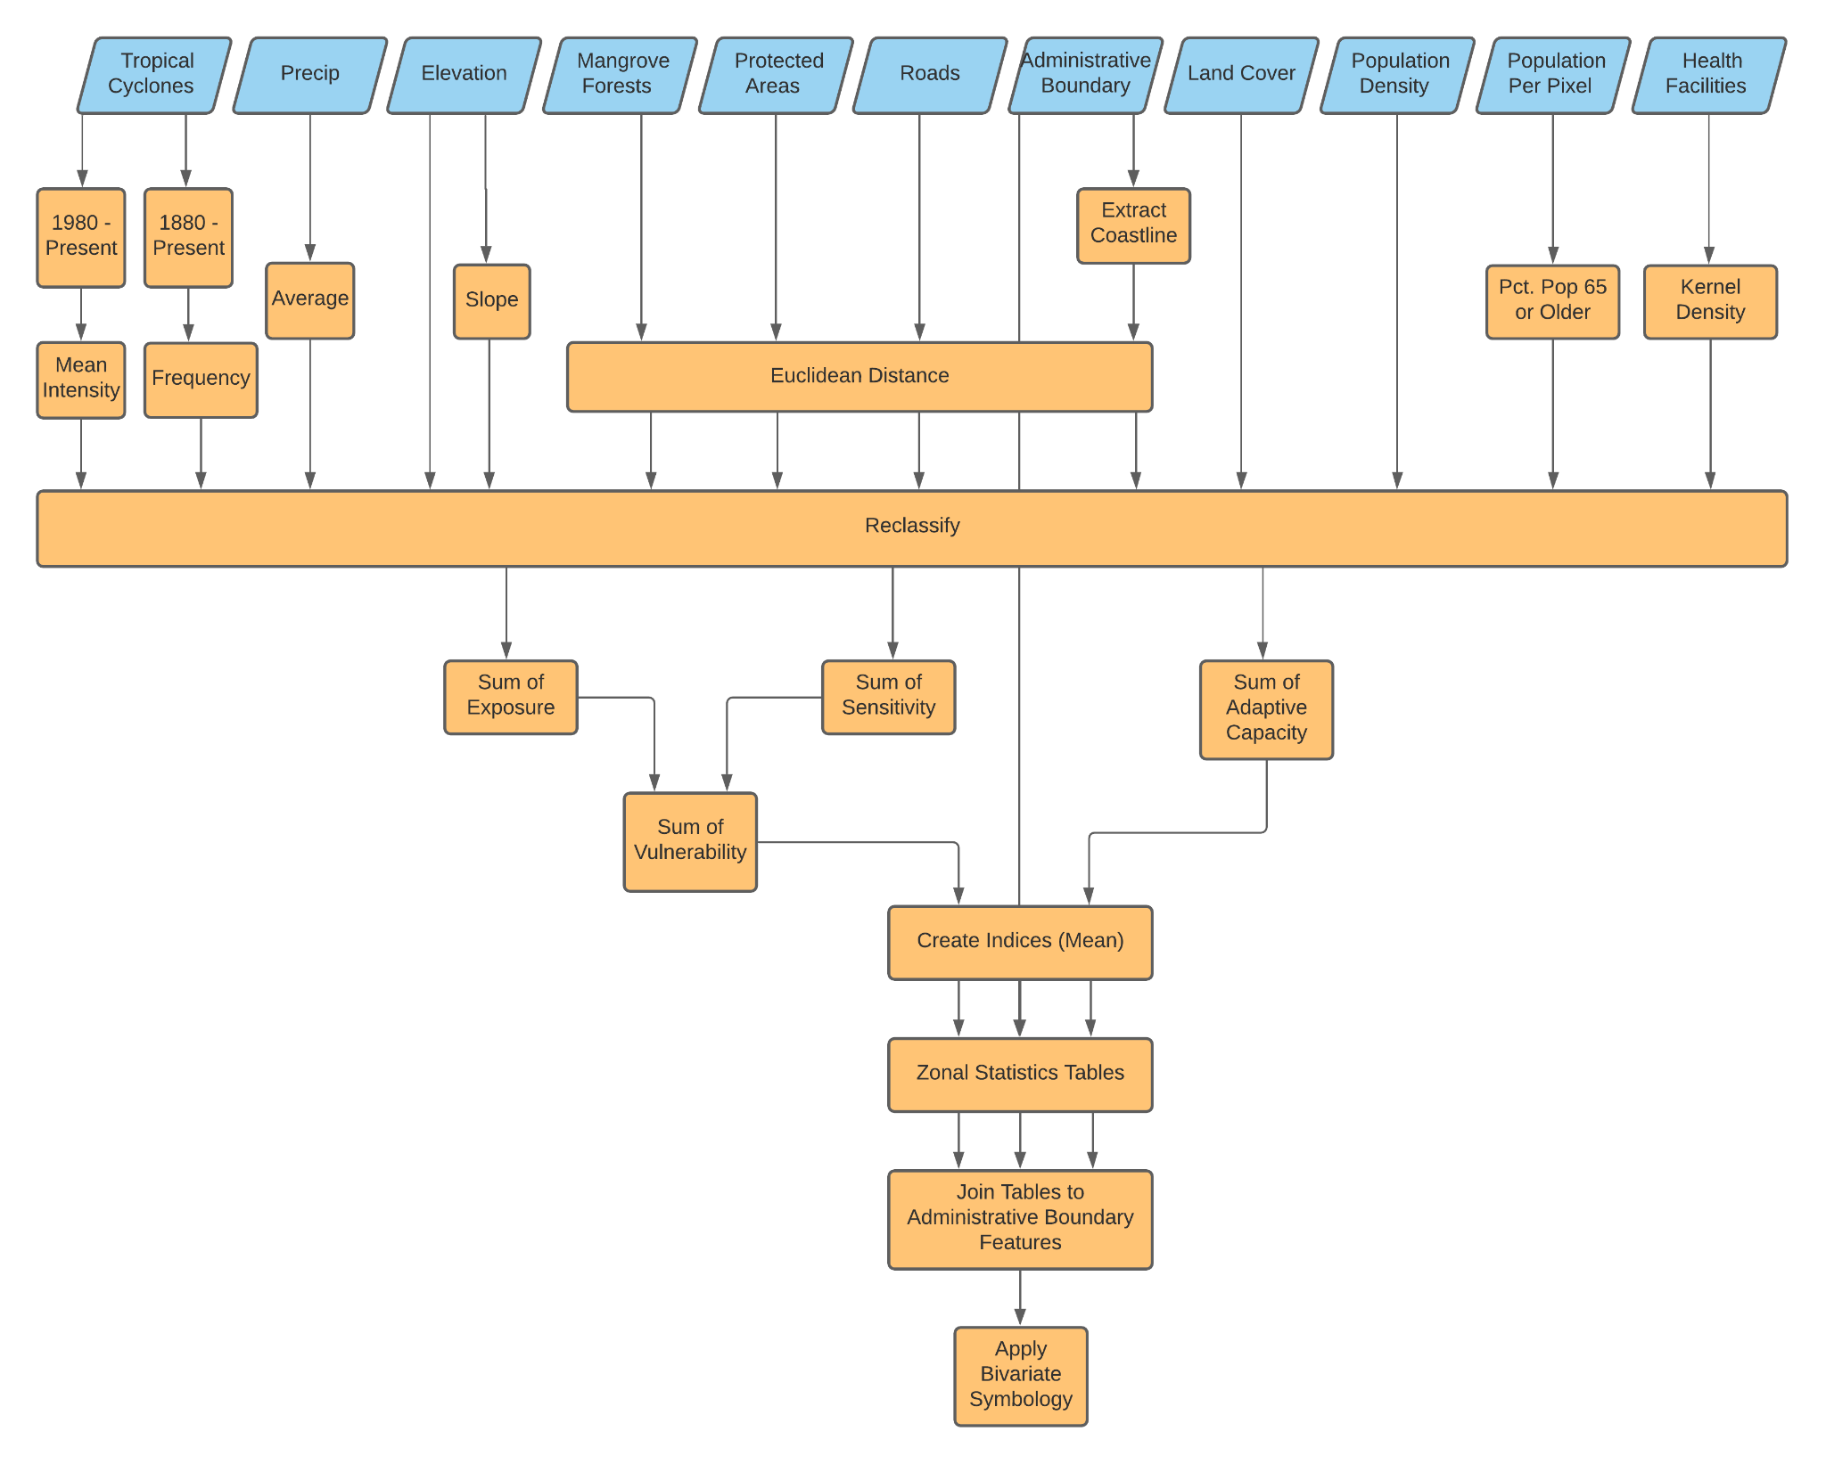Figure 2. Flowchart describing general methods and workflow.

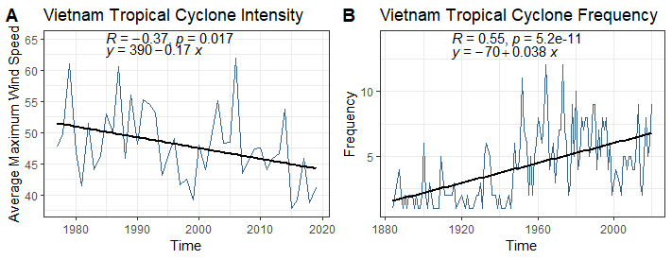

Figure 3. Tropical Cyclone Intensity (A), measured by average maximum sustained wind speed (knots), is presented with a decreasing trend from 1980 to present. Meanwhile, Tropical Cyclone Frequency (B) shows an increasing trend since 1880. Both figures represent tracks that have intersected with Vietnam rather than the entire West Pacific Basin.

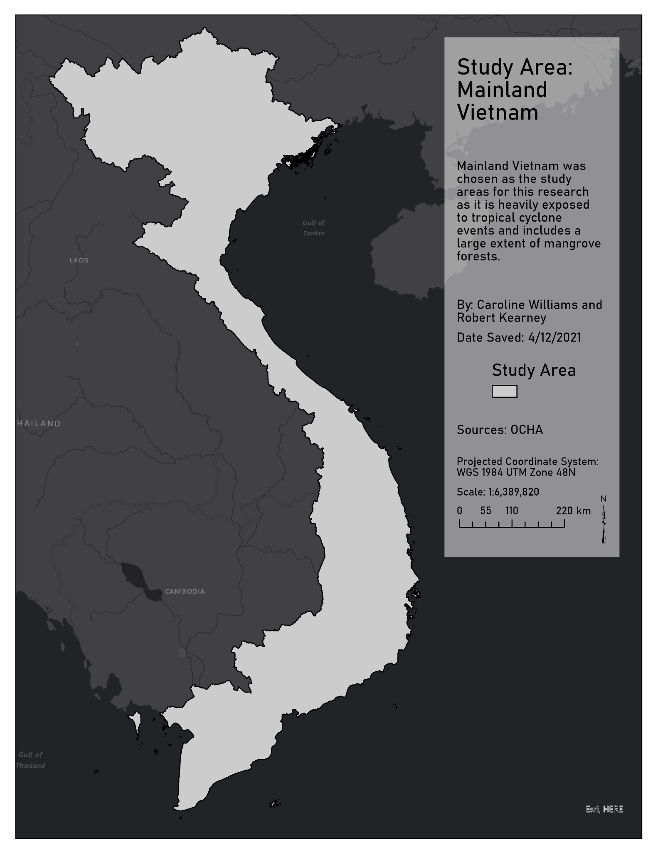

Figure 4. The study area of this research is of mainland Vietnam.

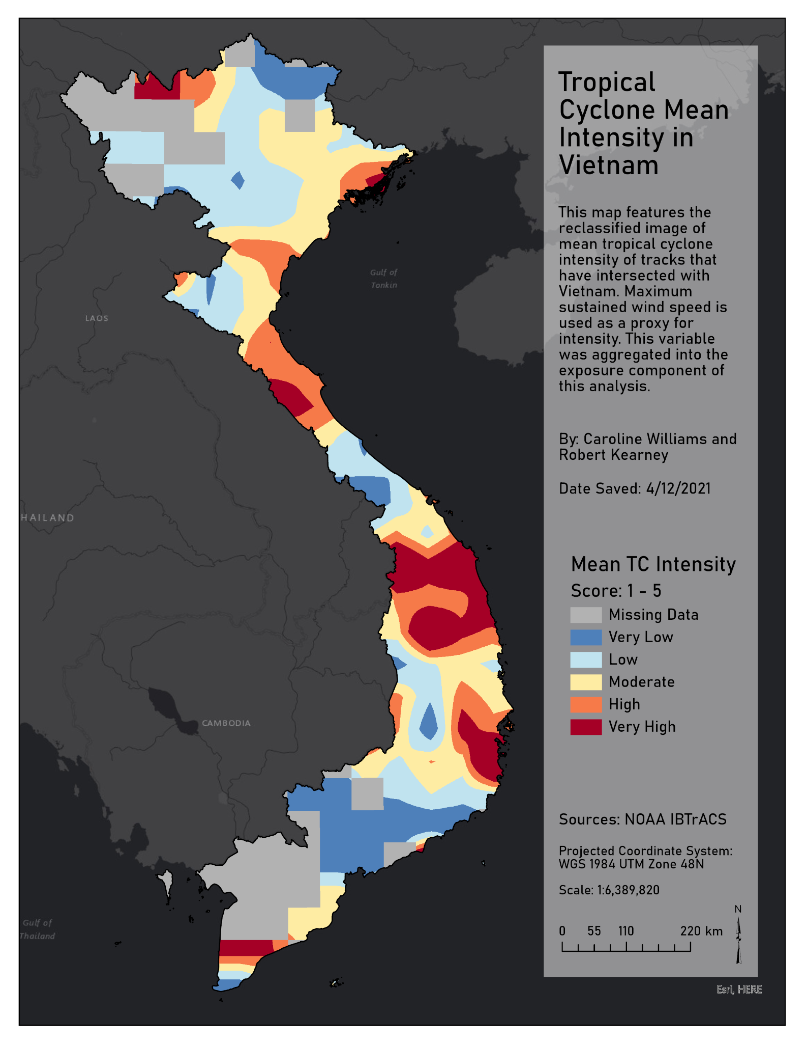

Figure 5. The reclassified image of mean tropical cyclone intensity is depicted. These classes correspond to the exposure component of vulnerability.

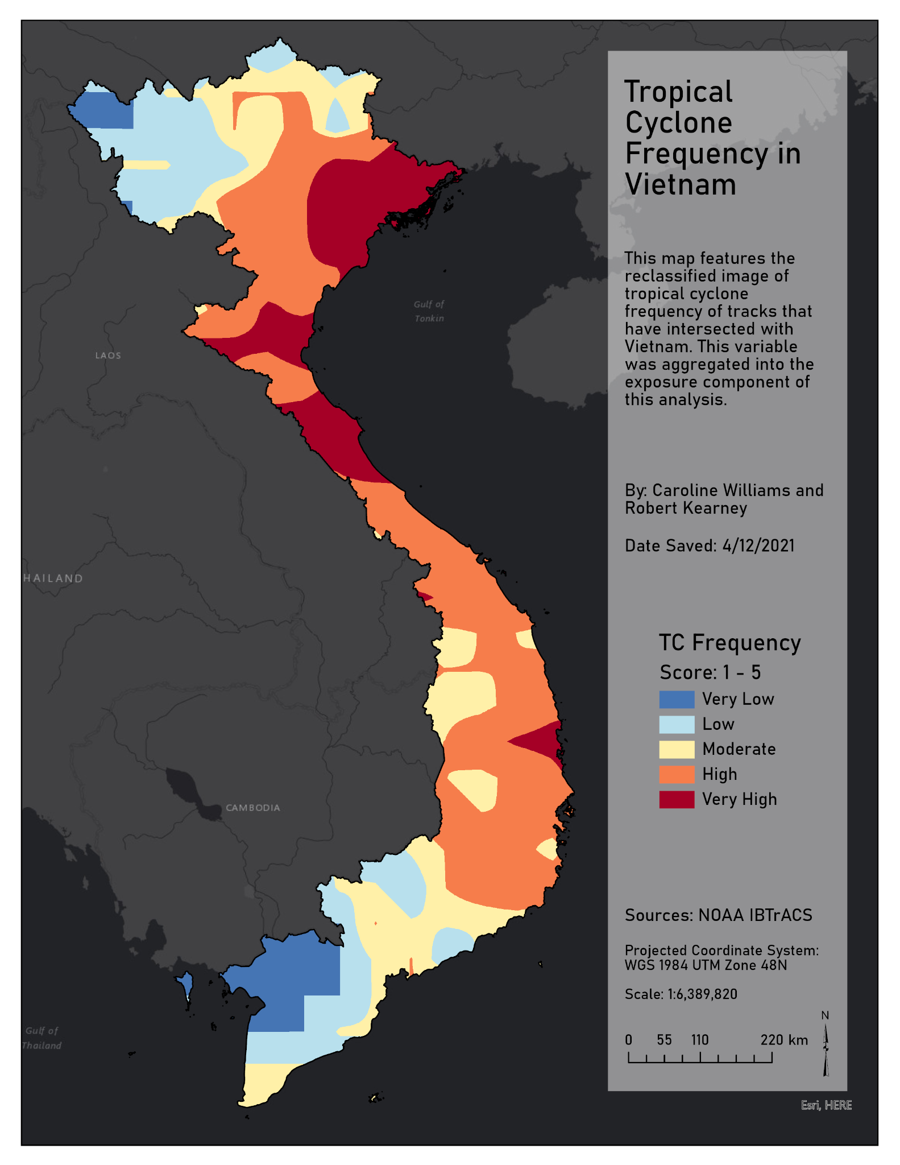

Figure 6. Tropical Cyclone Frequency is shown as a reclassified image making up exposure alongside several other climatic variables.

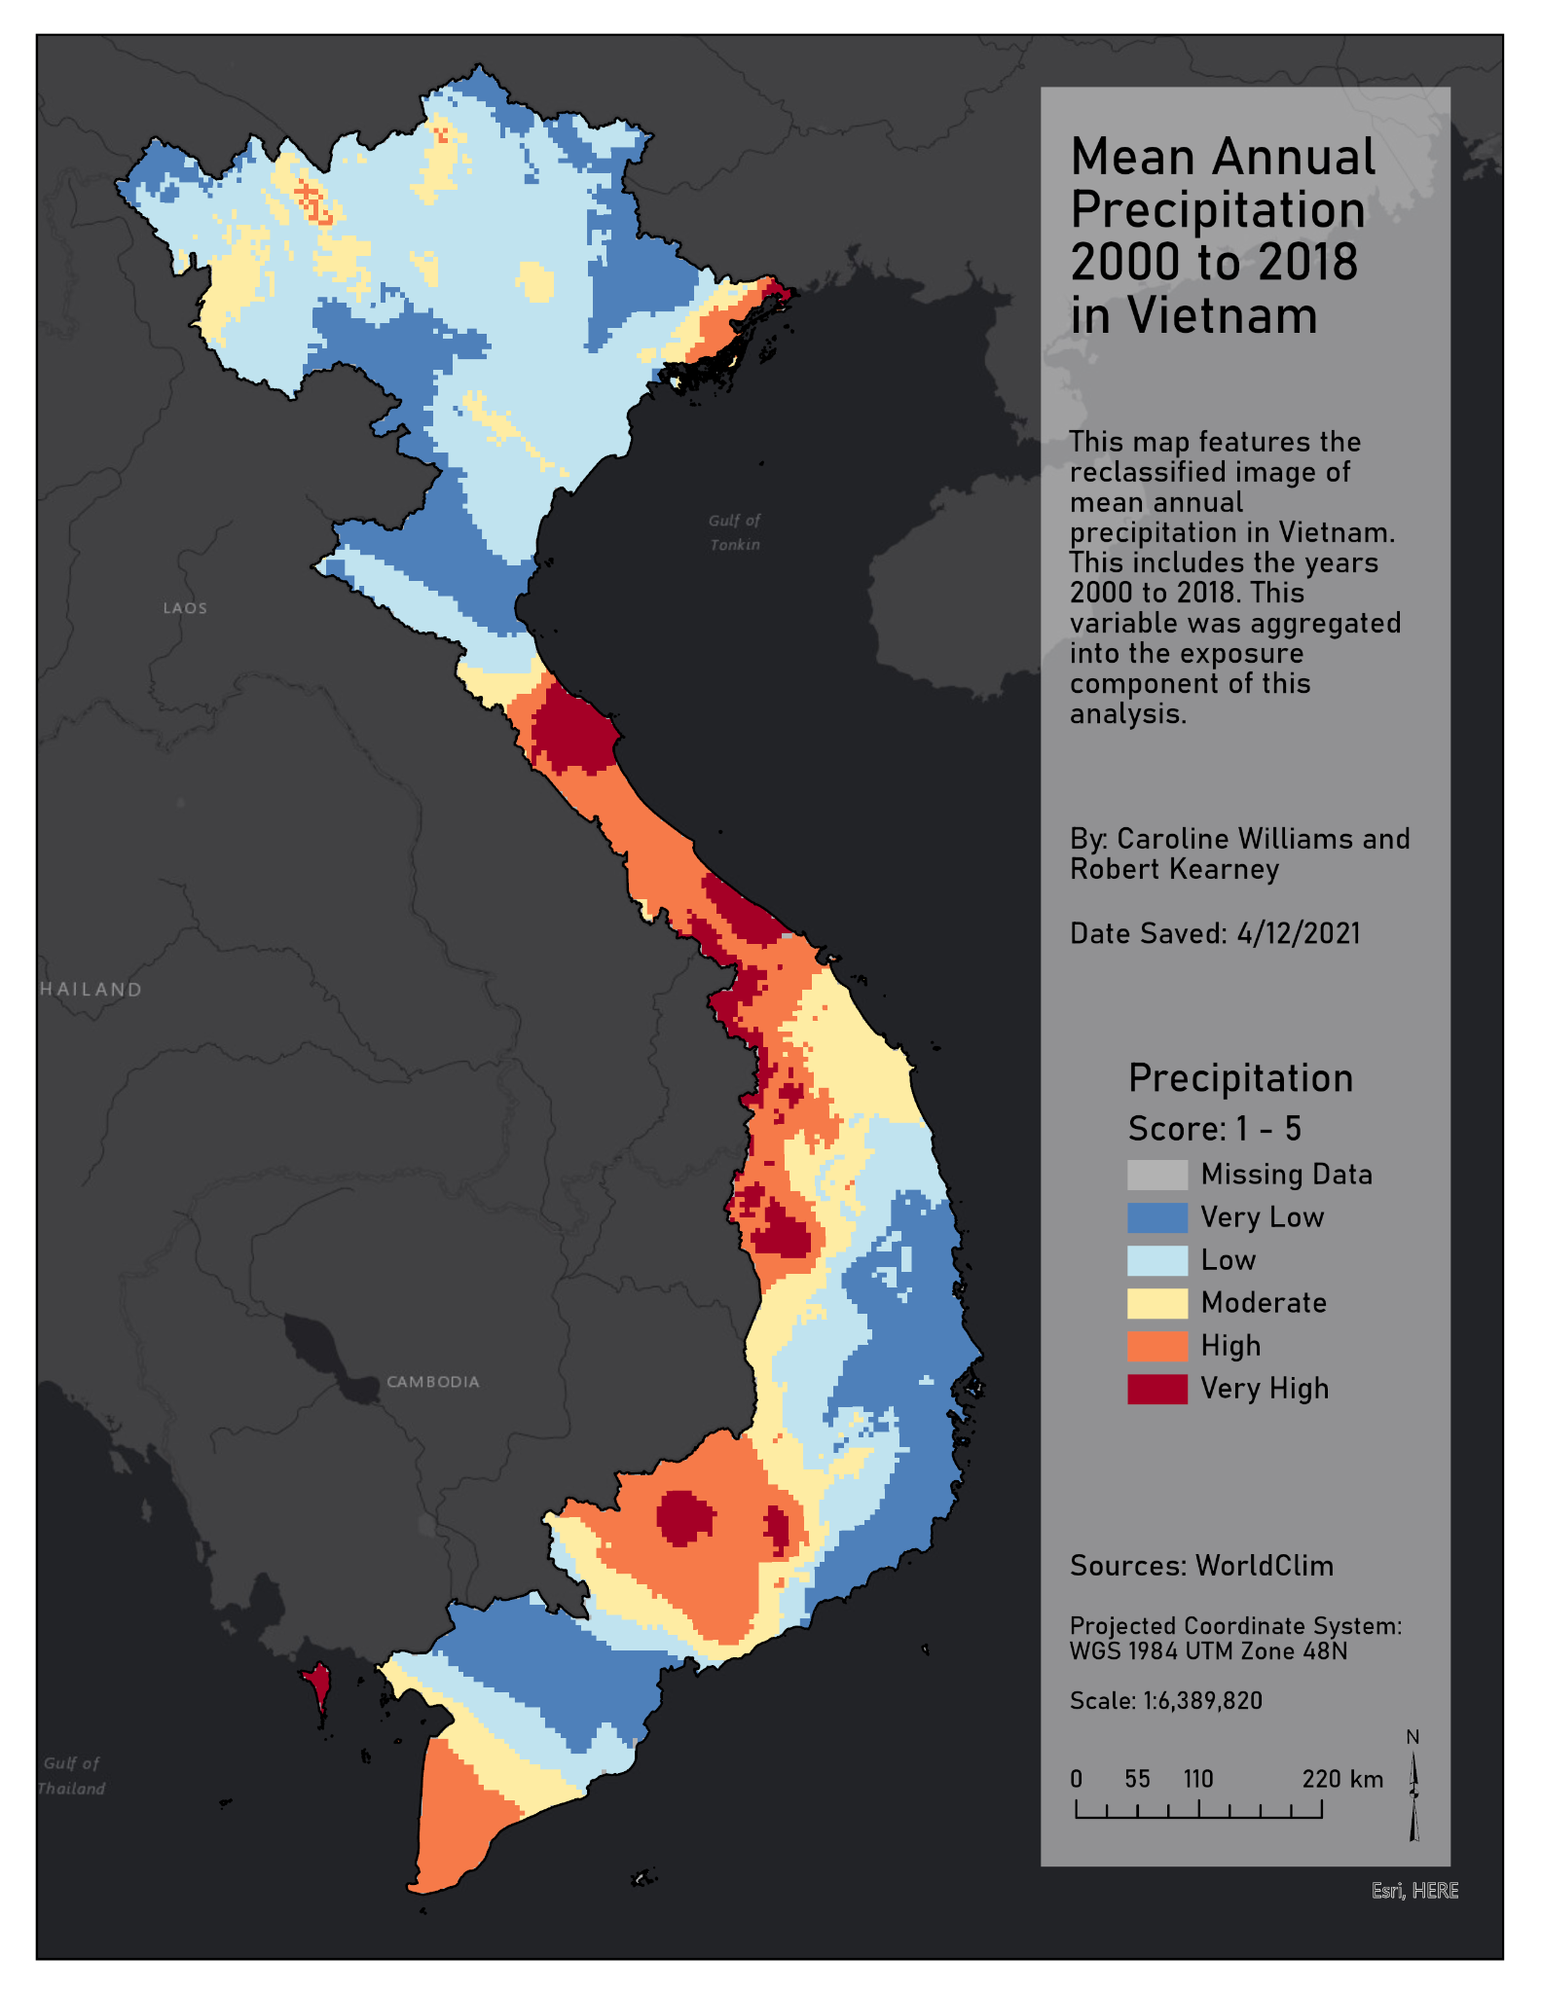

Figure 7. Precipitation is represented by mean annual values from 2000 to 2018. This reclassified image is a component of exposure.

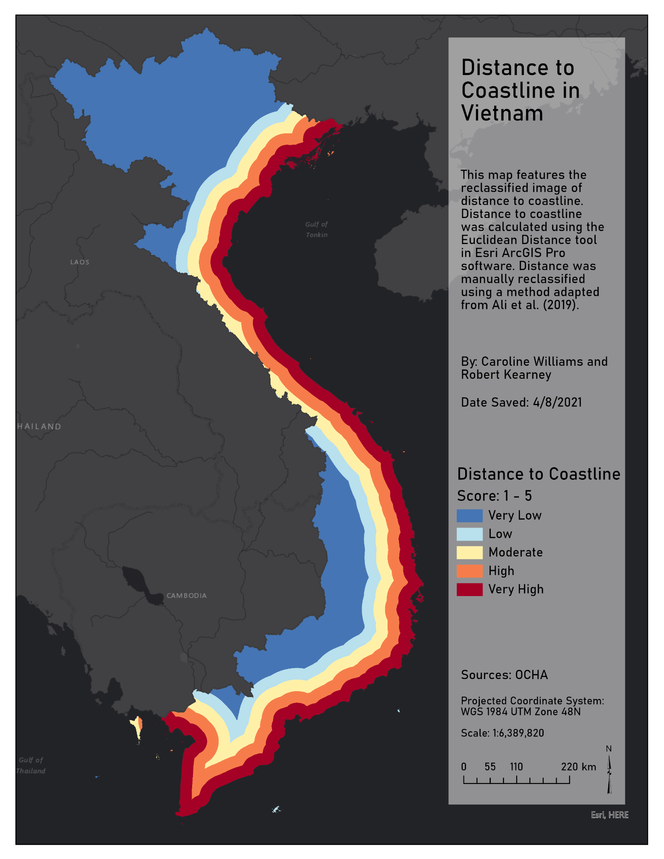

Figure 8. Distance to Coastline is reclassified here and used as a component to exposure.

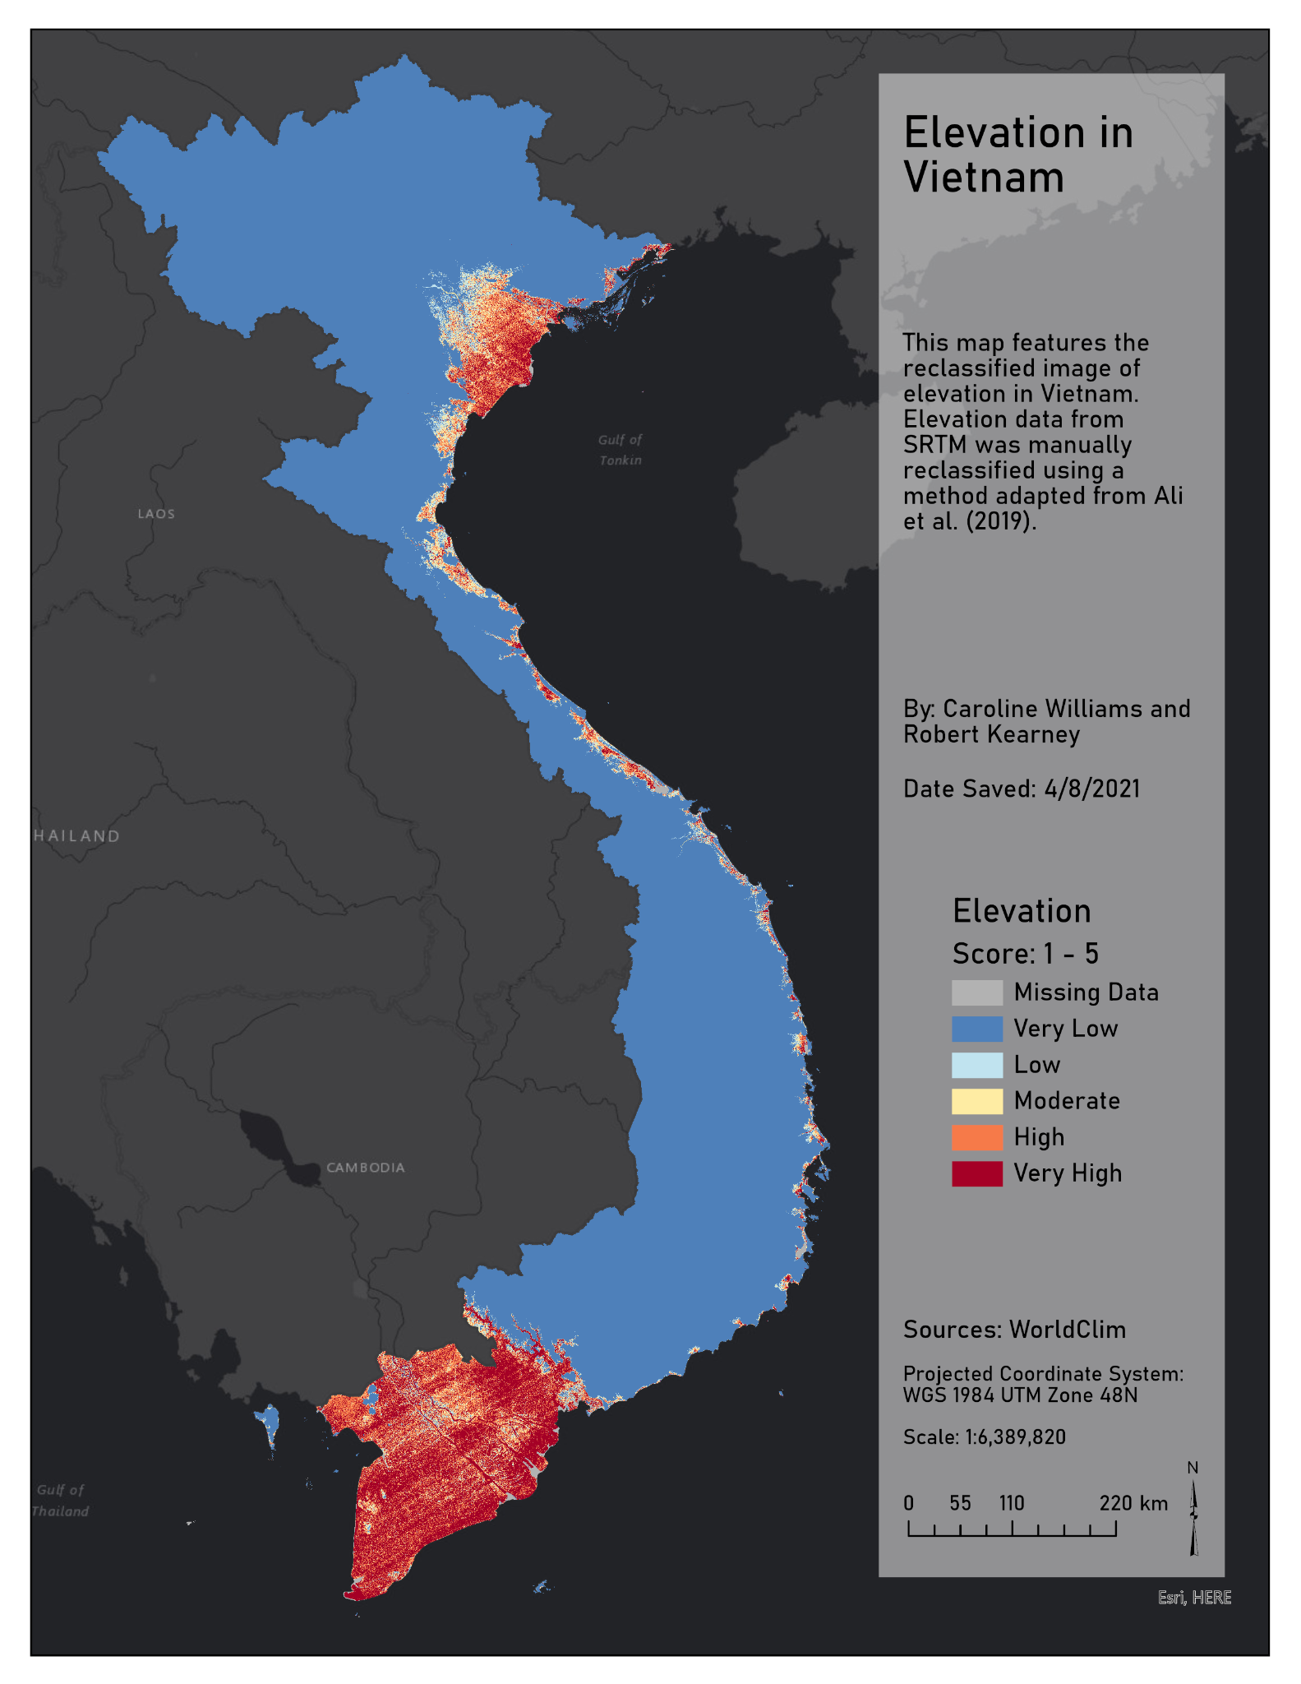

Figure 9. The reclassified image of elevation, a variable contributing to exposure,is depicted.

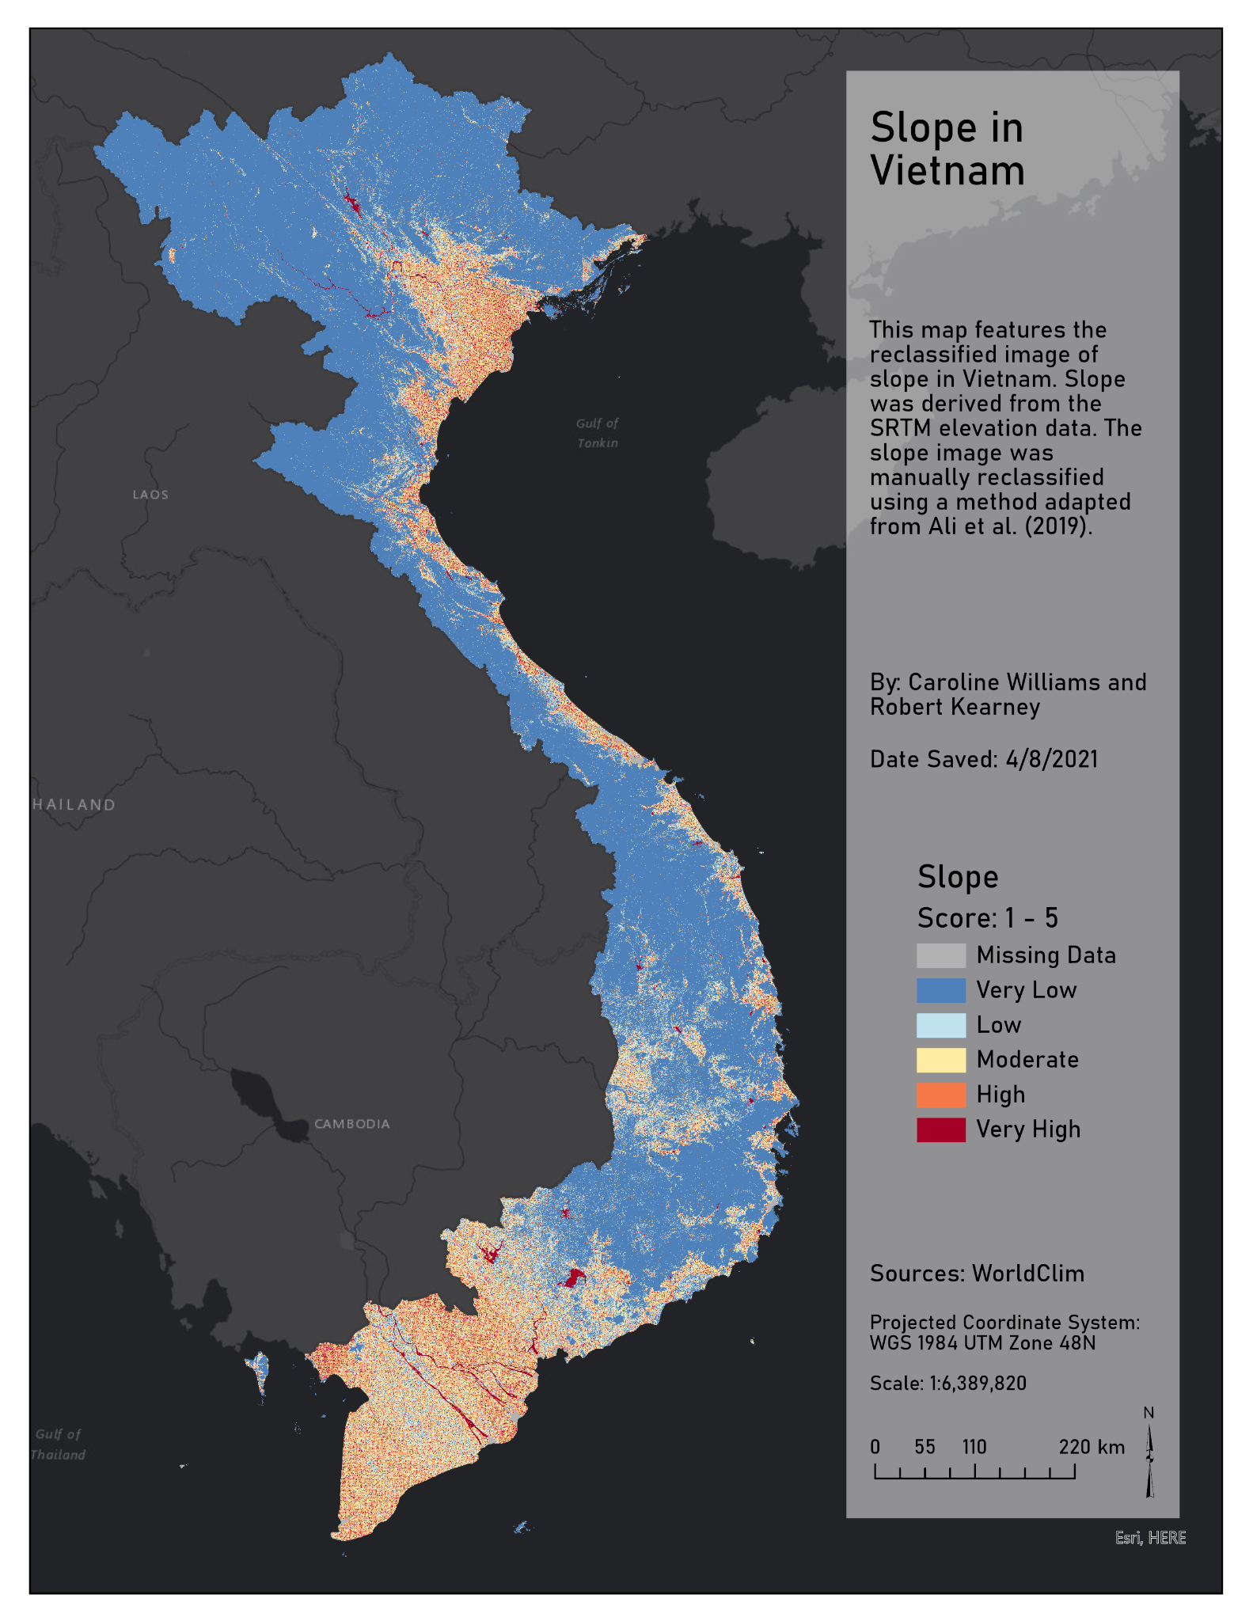

Figure 10. Slope is reclassified from 1 to 5 and incorporated to the exposure component of vulnerability.

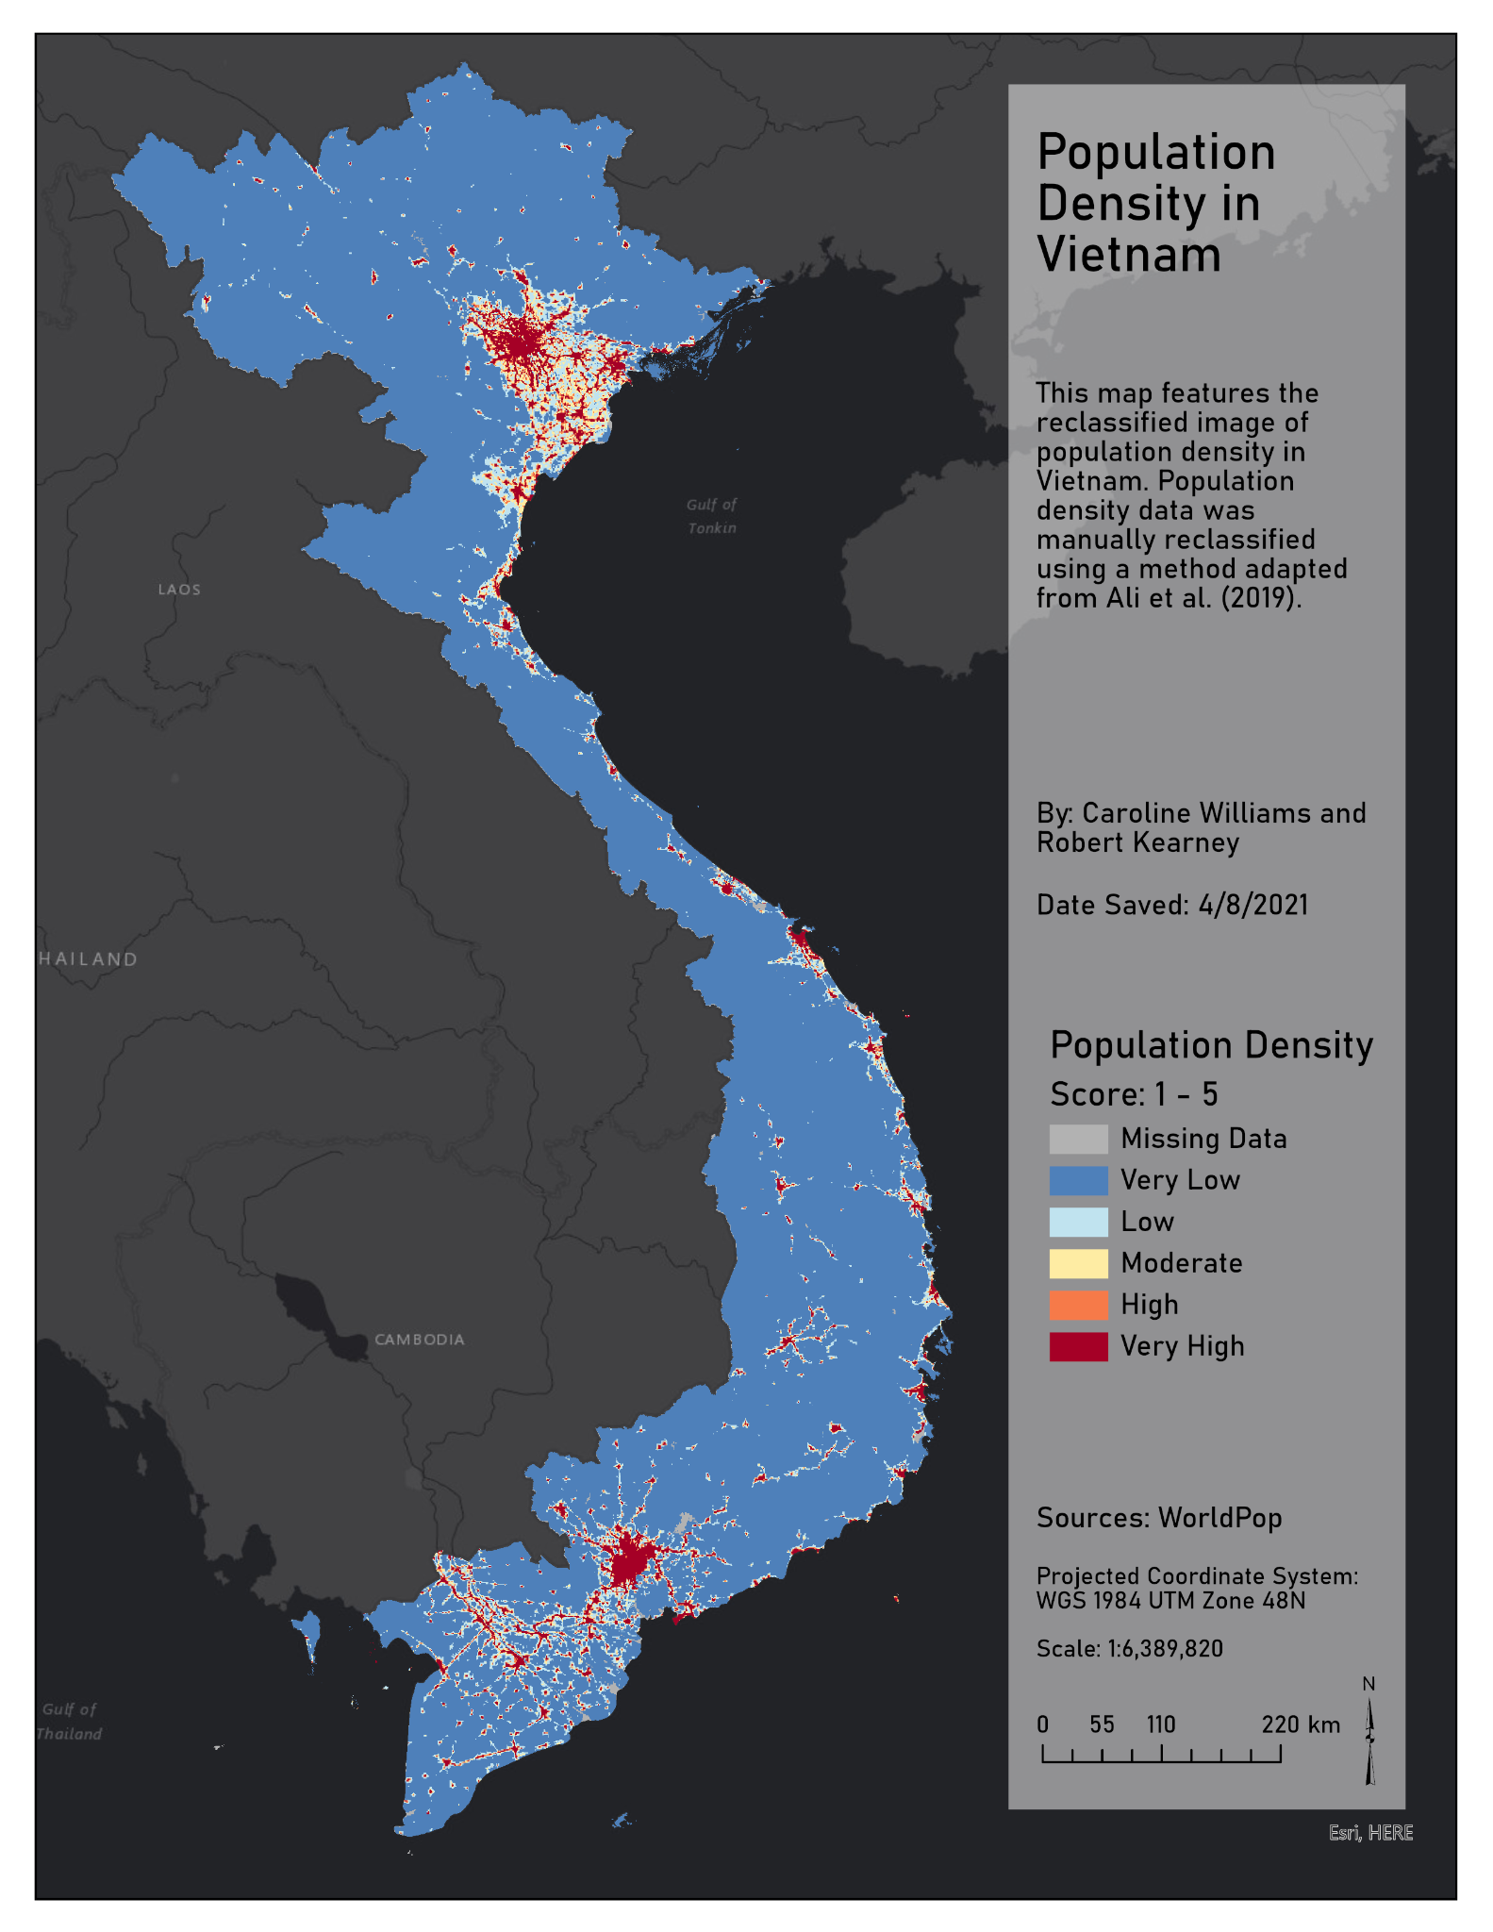

Figure 11. Population density, used as an exposure component, is reclassified from very low to very high exposure.

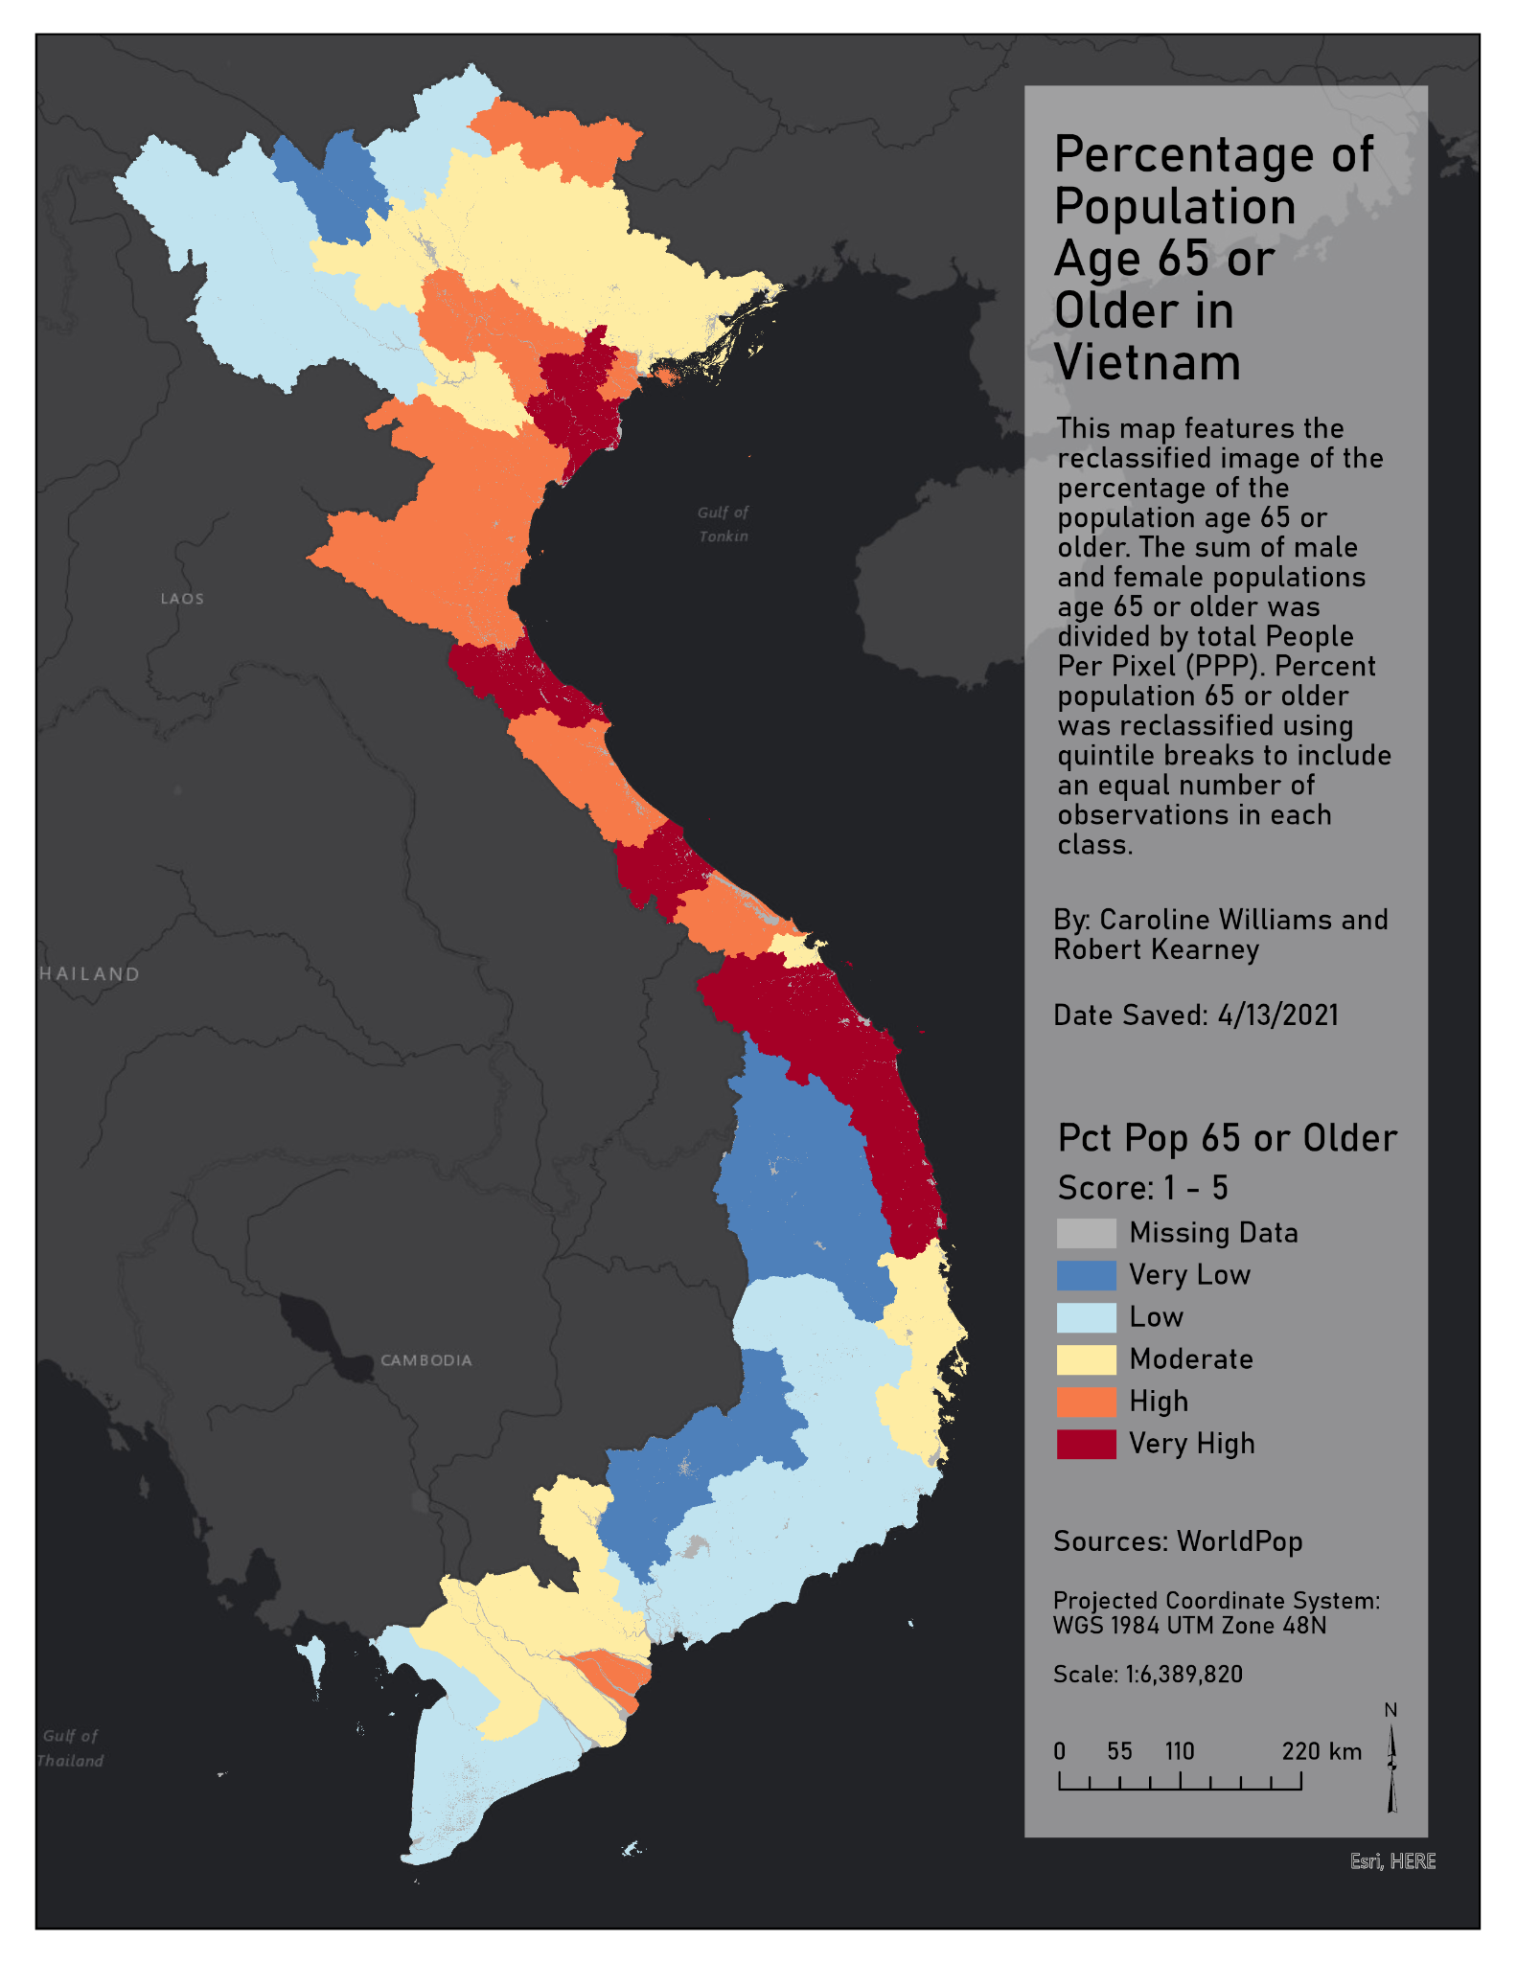

Figure 12. The percentage of populations over 65 years of age is reclassified and used as a variable aggregated into sensitivity.

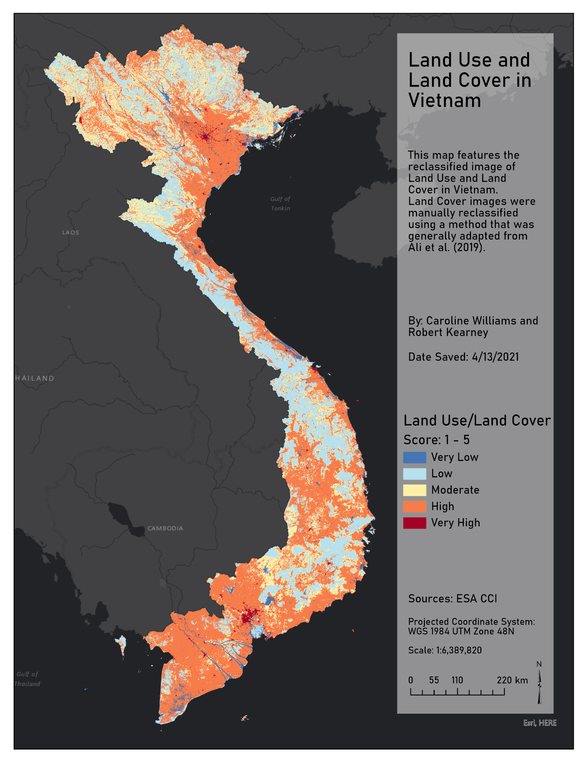

Figure 13. Land use and Land Cover (LULC) is derived from ESA CCI and reclassified based on class types at risk of exposure.

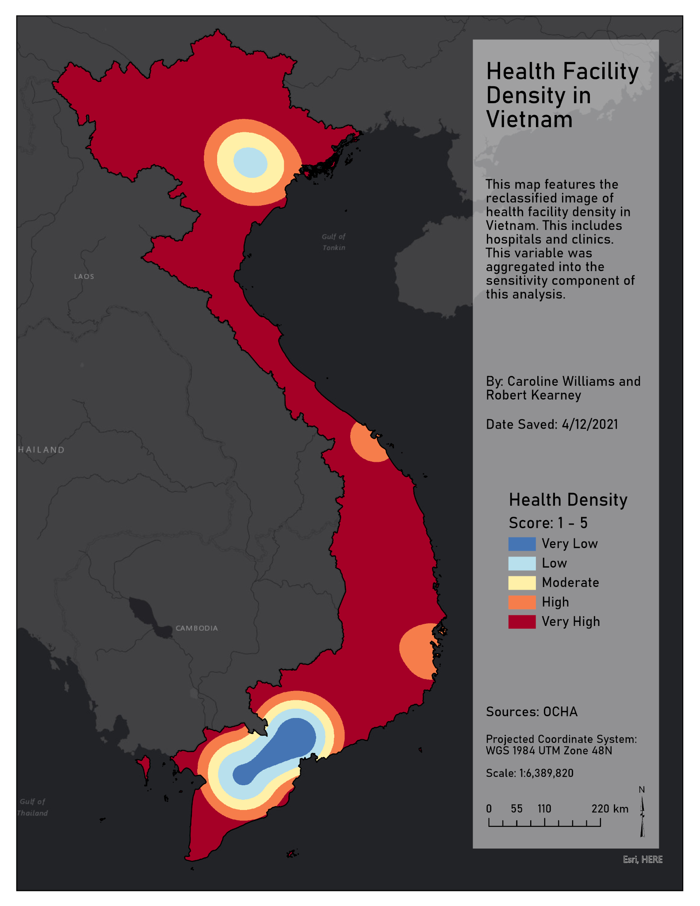

Figure 14. Health density is reclassified from the kernel density output on health care facility points. This layer is used in sensitivity.

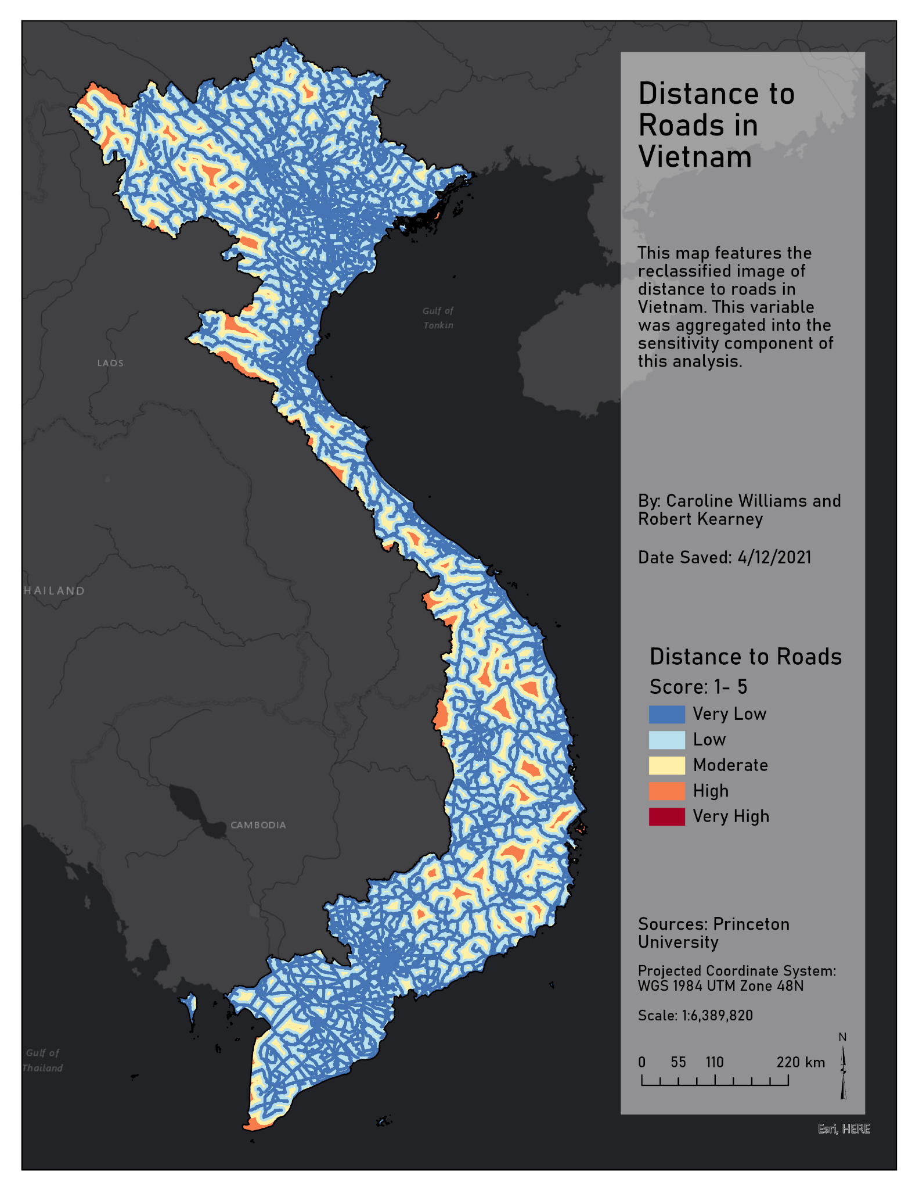

Figure 15. Distance to Roads is reclassified with farther distances represented as high sensitivity.

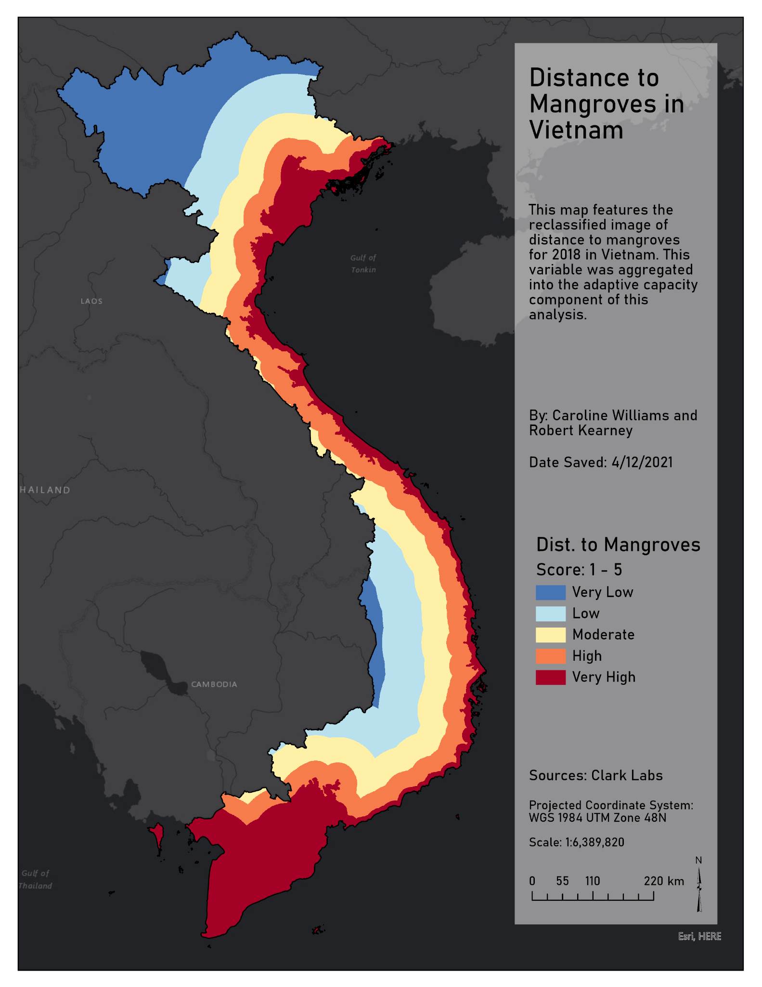

Figure 16. Distance to Mangroves shows high values as having the greatest adaptive capacity against tropical cyclone events.

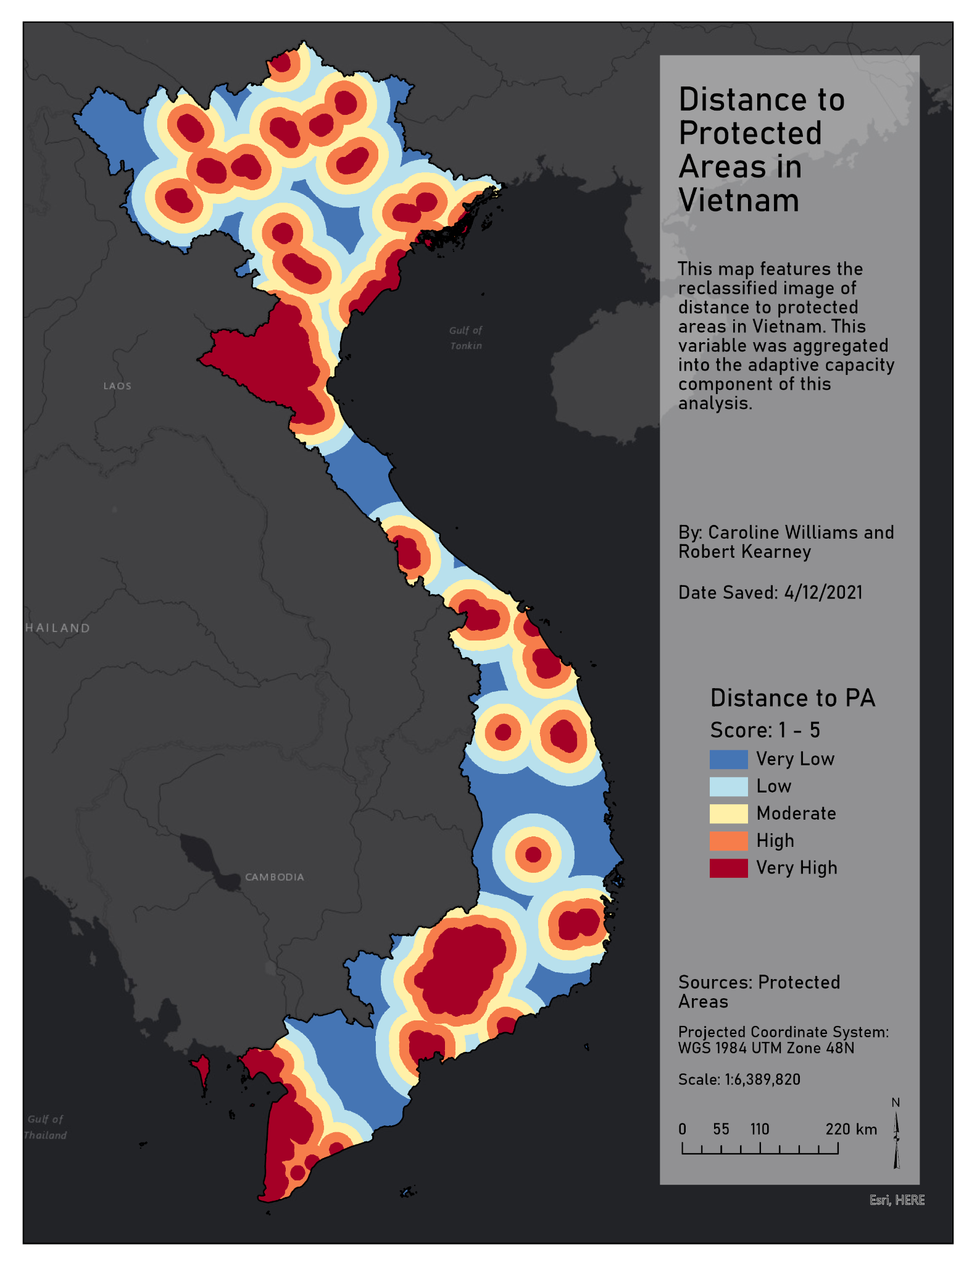

Figure 17. Distance to Protected areas shows areas close to protected areas being highly adaptive.

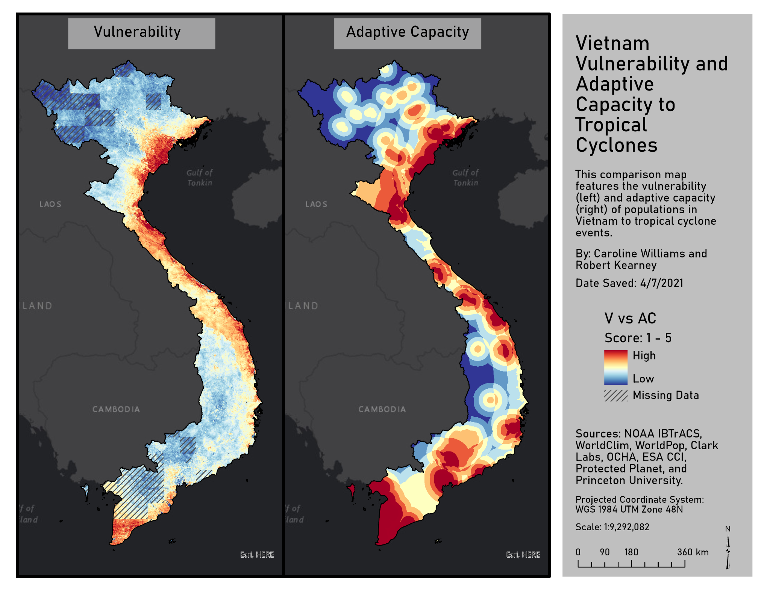

Figure 18. The final vulnerability map (left) and adaptive capacity map (right) are compared. High values depict high vulnerability and adaptive capacity.

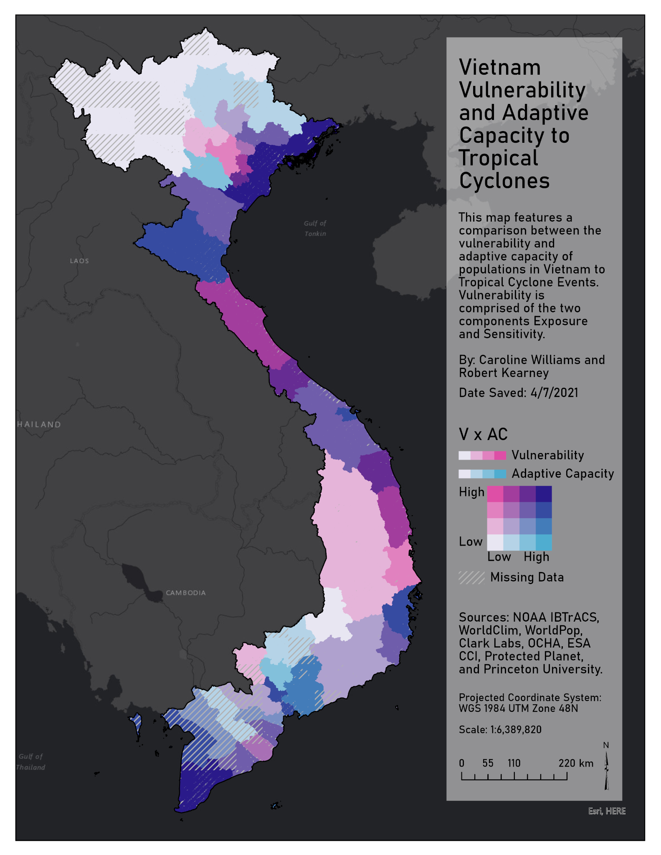

Figure 19. This bivariate map represents areas that are high and low in vulnerability and adaptive capacity. Dark colors represent high values while lighter colors depict lower values of the two indices.